Fact Finding Report
on
Public Health Centres in Ri-Bhoi and East Khasi hills Districts of Meghalaya
26th April, 2016

INTRODUCTION:
Indian Constitution provides right to health as one of the fundamental rights in corollary to right to life. Thus, denying basic health care means violating right to life. State being the guardian of the citizens’ rights has the duty to protect their legal and fundamental rights. Therefore, it is the basic duty of the state to provide basic health care services to the people and lead a healthy life.
Right to health was first articulated in the World Health Organization's (WHO) Constitution in 1946, which states that : "enjoyment of the highest attainable standard of health is one of the fundamental rights of every human being... And then in 1948 ‘health’ was introduced in Universal Declaration of Human Rights as a part of the right to an adequate structure of living (Article 25).” WHO has given a very comprehensive definition of the term “health.”
“Health is a state of complete physical, mental and social well-being and not merely absence of disease or infirmity. The enjoyment of the highest attainable standard of health is one of the fundamental rights of every human being without distinction of race, religion and political belief, economic or social condition.”
Though there is no distinction between men and women in respect of the right to good health and access to medical assistance, yet if one goes though the records relating to health, it shows the vulnerability of women who die of health issues, especially maternity related ones. The WHO defines maternal death as, “the death of a woman while pregnant or within 42 days of termination of pregnancy, irrespective of the duration and site of the pregnancy, from any cause related to or aggravated by the pregnancy or its management, but not from accidental or incidental causes.”
Further, WHO reported that over 90% of all maternal deaths are preventable if women receive access to basic antenatal care, skilled delivery assistance, and post-partum services. When governments fail to provide adequate maternal health care, they violate women’s rights to survive pregnancy, to health, to dignity, and to life.
With the objective of assessing the maternal health scenario in Meghalaya, a team of activists and lawyers visited Ri-Bhoi and East Khasi Hills districts, with intent to observe the functioning of Nongpoh Civil Hospital in Ri-Bhoi and some public health centres in East Khasi Hills.

Government of India's initiatives
The National Rural Health Mission (NRHM) is an initiative undertaken by the Government of India to address the health needs of under-served rural areas. It was launched in April 2005 by Indian Prime Minister Manmohan Singh. Under the NRHM, Northe East States have been given special focus. The NRHM is now a sub-mission of the National Health Mission.
Schemes such as the Janani Suraksha Yojana and Janani Shishu Suraksha Karyakram were launched under the NHM with its focus mainly on the maternal health and well-being of the child.
Also with focus on reducing maternal and child mortality, dedicated Mother and Child Health Wings with 100/50/30 bed capacity have been sanctioned in high case load district hospitals and CHCs which would create additional beds for mothers and children.
These schemes, under the NHM, focus on improving the health of pregnant and lactating women, and reduce the maternal and infant mortality rates.
The Janani Suraksha Yojana (JSY) launched on 12 April, 2005 was implemented by the Central government to lure pregnant women to opt for institutional deliveries and in the process improve the maternal health conditions in India.
It is a Centrally sponsored scheme and provides cash assistance for pre and post deliver care. A pregnant woman from rural area is given Rs. 1400 and that from urban area is given Rs. 1000 for delivery in Govt. and accredited hospitals. Rs. 500 is given for home-delivery by BPL women. Also the relevant ASHA worker gets Rs. 600 for every delivery in Govt. and accredited hospitals.
The Janani Shishu Suraksha Karyakram (JSSK) was launched by the Government of India on 1st June, 2011.
This scheme supplements the cash assistance given to a pregnant woman under Janani Suraksha Yojana (JSY) and is aimed at mitigating the burden of out of pocket expenses incurred by pregnant women on herself and sick newborns.
The following are the free entitlements for pregnant women:
- Free and cashless delivery
- Free C-Section
- Free drugs and consumables
- Free diagnostics
- Free diet during stay in the health institutions
- Free provision of blood
- Exemption from user charges
- Free transport from home to health institutions
- Free transport between facilities in case of referral
- Free drop back from Institutions to home after 48hrs stay

The following are the Free Entitlements for Sick newborns till 30 days after birth. This has now been expanded to cover sick infants:
- Free treatment
- Free drugs and consumables
- Free diagnostics
- Free provision of blood
- Exemption from user charges
- Free Transport from Home to Health Institutions
- Free Transport between facilities in case of referral
- Free drop Back from Institutions to home

The National Food Security Act, 2013 (also Right to Food Act) is an Act of the Parliament of India which aims to provide subsidized food grains to approximately two thirds of India’s 1.2 billion people.
Further, the NFSA 2013 recognizes maternity entitlements. The Midday Meal Scheme and the Integrated Child Development Services Scheme are universal in nature whereas the PDS will reach about two-thirds of the population (75% in rural areas and 50% in urban areas).
Pregnant women, lactating mothers, and certain categories of children are eligible for daily free meals.

Methodology:
Lawyers and Social Activists from HRLN conducted a fact-finding on 26th April, 2016. The fact-finding team interviewed staff of Nongpoh Civil hospital at Nongpoh at Nongphoh, Ri-Bhoi, and Mawryngkneng Primary Health Centre at Mawryngkneng, East Khasi Hills. the team also visited the Mawlyngad Sub-Centre but it was closed at the time of the visit. Further, pregnant women and new mothers of newborns were interviewed. This fact finding report is based on both primary and secondary source of information. Interviews were used as the primary method to collect information in the fact finding visit. Apart from the primary data, we also analysed reports and academic literature as secondary sources of information.

District Profile
Ri-Bhoi
Ri Bhoi District is one of the youngest Districts of Meghalaya which came into existence and assumed the hierarchical status of the District on the 4th June 1992 by upgrading the former Civil Sub-Division. The District was carved out from the erstwhile East Khasi Hills District and lies between North Latitudes 25 15’ and 26 15’ and between East Longitudes 91 45’ and 92 15’. Presently, the District is bounded on the North by the Kamrup, Morigoan and Nagaon Districts of Assam, on the East by the Karbi Anglong District of Assam, on the South by East Khasi Hills & West Khasi Hills Districts and on the West by the West Khasi District. Nongpoh is the District headquarters. Ri Bhoi District contains an area of 2448.00 Sq. Kms.
Ri-Bhoi has a total population of 1,92,795 of which 99,315 were males and 93,480 were females. The overall literacy rate of the district is 65.7%.

East Khasi Hills
East Khasi Hills District forms a central part of Meghalaya and covers a total geographical area of 2,748 Sq. Kms.. It lies approximately between 25°07” & 25°41” N Lat. and 91°21” & 92°09” E Long.
Shillong is the district headquarters of East Khasi Hills District. The district consists of Eight Community and Rural Development blocks at present.
The East Khasi Hills District is mostly hilly with deep gorges and ravines on the southern portion. The most important physiographic features of the district is the Shillong Plateau interspersed with river valley, then fall sharply in the southern portion forming deep gorges and ravine in Mawsynram and Shella-Bholaganj bordering Bangladesh. Shillong peak lying 10 Kms. from the city, offer a panoramic view of the scenic country side and is also the highest point in the district as well as in the State.
It has a population of 8,24,059 consisting of 1,60,832 households, and a literacy rate of 84.70%.

Fact Finding:

Ri-Bhoi
A team from HRLN visited Nongpoh in the early hours of 26th April, 2016. Our aim was to extract information regarding the functioning of Public Health Centres there.
Our subject was the Nongpoh Civil Hopital at Nongpoh, Ri-bhoi district. It was around 8 in the morning when we reached there. Just to look at, the hospital was quite impressive. It was quite a contradiction to the notions we have formed about Government Hospitals. A little recce of the hospital confirmed that the place was well maintained and clean. The hospital was an 80 bedded one. It was upgraded to a District Hospital in the year 2004.
On enquiring, we were helped to the doctor's chambers. There was one doctor present there in those early morning hours. The doctor was a short fellow and was co-operative. He agreed to answer all our queries to his possible best.
The rest of the information we gathered weren't as impressive as our initial impression of the hospital.
We learnt that there were sporadic incidents of infant deaths in the district. Also, there had been one reported case of Maternal Mortality in the past couple of months. In this case, one woman from a nearby village had delivered a child at home. She had grown weak during the period of delivery. Soon after the delivery she was rushed to the hospital but it was already too late. She could not be saved.
In the hospital’s maternity ward, there was just one lady admitted then. We talked to her and enquired about her health conditions. She appeared reasonably healthy. Also, we learnt from her that she had undergone 4 Ante-Natal Check-ups (ANCs), which was the prescribed number of check-ups.

Facilities lacking
· As per IPHS guidelines, a District hospital must have an Operation Theatre. Though this Hospital did have an Operation Theatre, it lacked proper amenities and thus hardly any operations were conducted there. The ones which were conducted were minor ones. Most cases requiring an operation were thus referred to Ganesh Das Hospital at Shillong. Thus this was a major drawback of the hospital.
· It is mandatory for a District Hospital to have a Blood Bank. This hospital does not have one. It does have a Blood Storage Facility.
· Concerning the availability of manpower, a District Hospital is supposed to have 2 Anaesthesia specialists but this hospital did not have any. It did not have any medicine specialist, where there should have been 2. Moreover, there was just one Paediatrician, where it is supposed to have 2. The Hospital had not employed any radiologist, but it is mandatory for a District Hospital to have at least one radiologist. Thus, from this we were able to decipher that the hospital was lacking in manpower.
· A pregnant woman is supposed to get transport facilities for pregnancy related check-ups and health centre visits. But in most cases, the pregnant women had to arrange for their own means of travel.
· The generator in the hospital is dysfunctional, thus is no back-up during power-cuts.

Thus, from the above points, we have observed that there is scope for improvement in the hospital’s facilities and services. Especially, it is essential for the hospital to improve its manpower and to equip its Operation Theatre at the earliest. Otherwise, it causes harassment to the public and is time-consuming to refer a patient to a better equipped hospital under critical conditions. All violations of the IPHS guideline must be set right.

East Khasi Hills

Mawlyngad Sub-Centre
We arrived in Shillong at around 11 a.m. From there we headed to a village named Mawlyngad. Mawlyngad has a sub-centre but it was closed when we arrived. We were informed that Tuesday is a holiday for the sub-centre’s employees. Nevertheless, we were able to gather some information about it from the neighbours. We learnt that there was 1 ANM serving there. There were no quarters provided for any of the employees due to lack of space. Ante-natal Check-ups(ANC) were carried out on Fridays. The sub-centre has a regular ASHA worker and it also serves as an Anganwadi. The sub-centre does not have a labour room. For child deliveries and issues, patients are referred directly to the Ganesh Das Hospital in Shillong.

Meeting pregnant Women & New Mothers
From Mawlyngad, we headed to a little village called Puriang. We were at Iewrim locality of the village, to be more specific. Located a little distance coming in from the highway amidst vast tracts of meandering pine-covered hills, it is a sight to behold.
We met the ASHA worker of the locality, Ibadarihun. She guided us throughout our brief stay there.
We visited the house of one, Ridabha Kshiar. Ridabha was 32 years old and had recently delivered twins. This had been her 8th pregnancy. We discovered that Ridabha was anaemic. All these bouts of pregnancies had taken a toll on her body. She appeared weak, although her babies were healthy.
Her delivery had been at Ganesh Das Hospital, Shillong, and she had been referred to the place by the local PHC at Mawryngkneng. Ridabha had a normal delivery there, but she had been released after one day of the delivery, in violation of the 48 hour post-delivery observation period advised by the Government. We checked her medical papers and observed that it was written therein that her discharge is on the basis of the patient’s request, but on asking her she refused making any such request. This indicated to a case of consent being obtained through misrepresentation.
She also told us that she had gone to the PHC from her home before delivery on an ambulance, and again from the PHC to Ganesh Das Hospital in the same ambulance. But after discharge, she had to hire her own vehicle from the hospital to reach home.
Her medical papers indicated that she had undergone 4 ANCs at the local PHC. During all her visits to the PHC for ANC, she had to arrange for her own travel at her own expense.
Ridabha told us that neither had she got rations nor Rs. 6000 under the FSA. Also, she did not get the 1400 rupees that she is entitled to under the JSY scheme.
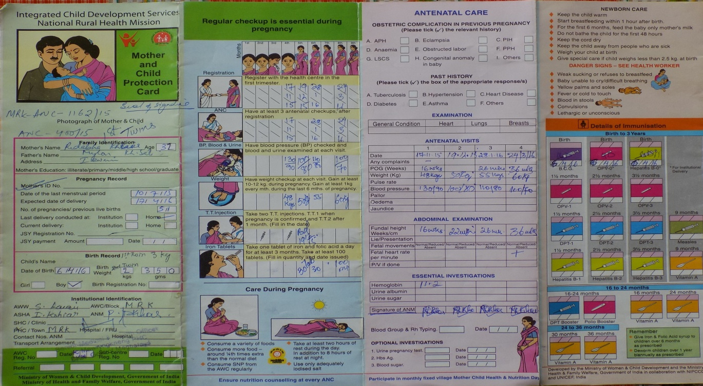
Mother & Child protection Card of Ridabha Kshiar

The next house we visited was one of Ms. Bioka Marboh. Bioka, also aged about 32 years, was into her 6th pregnancy. Bioka’s husband was a farmer and the sole bread-earner of the family. Their monthly income was around 5000 rupees.
All her previous deliveries had been at home and normal. Currently, she was 8 months pregnant. She showed us her medical papers and we learnt that she had undergone 3 ANCs up till then. But despite the 3 ANCs, her Blood Pressure had been only checked once. She had received iron and folic acid tablets and was taking them regularly. There weren’t any further complications. She had also been tested for HIV.
Bioka told us that although she did receive some rations from the local Anganwadi but the supply was erratic. She also did not get the 6000 rupees which she is entitled to under the Food Security Act.

From the above two cases, we learn that the Central Government schemes, Janani Suraksha Yojana(JSY) and Janani Shishu Suraksha Karyakram(JSSK), have not been implemented properly yet. There are violations of the Food Security Act, 2013. Also the IPHS are not being complied with by the Public Health Centres. The intended beneficiaries of these policies are not being benefited.

ICDS Centre, Iewrim
We visited the ICDS centre at Iewrim, Puriang Village. It is perched on a picturesque hillock and is basically a small one-roomed house with a kitchen. There was no proper signboard to identify the place. The centre was locked when we visited. But the local ASHA worker accompanying us was able to fetch its keys, and opened its doors for us to inspect.
We observed that there is a water tank right next to centre for water supply. But there was no water in the tank. We were also informed that water supply to village is poor and people have to walk a long distance to fetch water. Thus, the lack of water supply hindered preparation of food at the ICDS centre.
There were stocks of food grains in the centre. But from what we could gather from the locals, the supply of food to those in need was erratic. Ms. Bioka Marboh, who was a resident of Iewrim, informed us that during her pregnancy she had not received adequate supply of nutrition from the ICDS centre. She had received a little quantity of ration but it was not sufficient. She also did not receive Rs. 6000, which she is entitled to under the Food Security Act, 2013.
Thus it shows a violation of the right to quality, adequate and nutritious food of every mother and child of Iewrim village. Prodding is necessary to implement the various Acts judiciously.
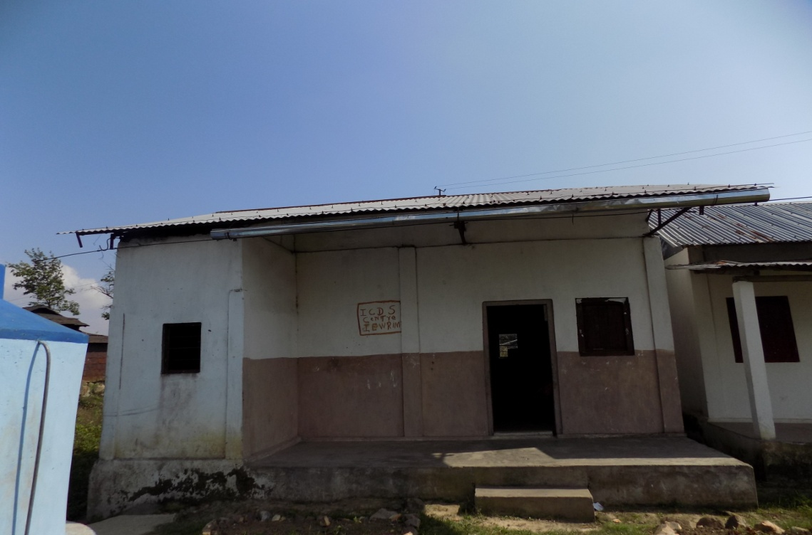
ICDS Centre, Iewrim
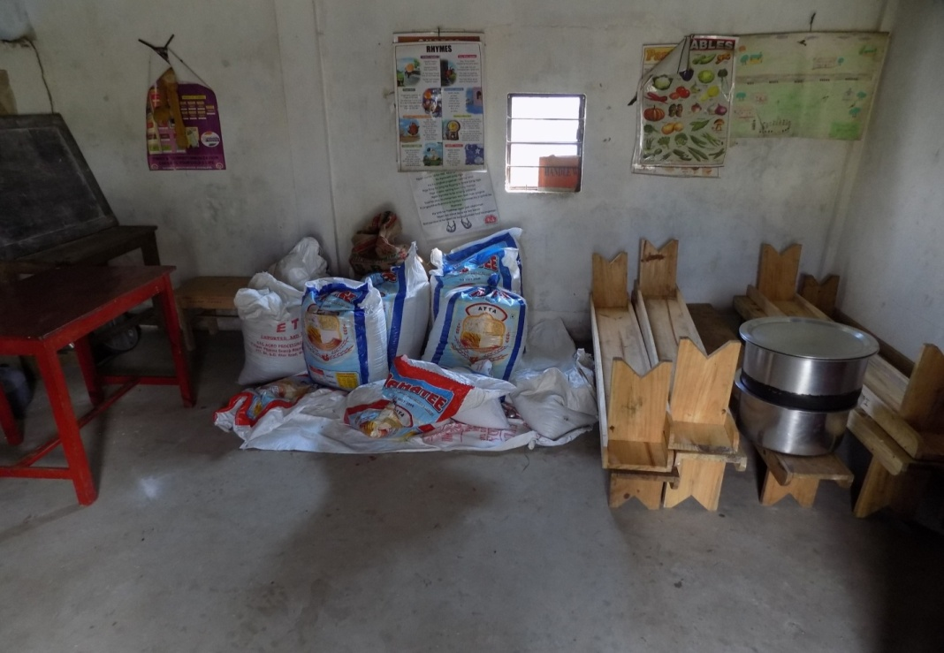
Food stock inside the ICDS Centre, Iewrim

Mawryngkneng Primary Health Centre(PHC)
The PHC at Mawryngkneng was undergoing repair work when we visited. Thus, it was currently only offering OPD services. The PHC has a labour room, but it too was not functioning currently for repair works. Although the medical personnel claimed that emergency cases could be handled. There haven’t been any recent maternal deaths in the area covered by the PHC. The PHC did not have sufficient ward boys/girls at present. There were 3 doctors currently engaged in the PHC. Two of them were MBBS and one AYUSH. All the staff members had been provided with residential quarters.
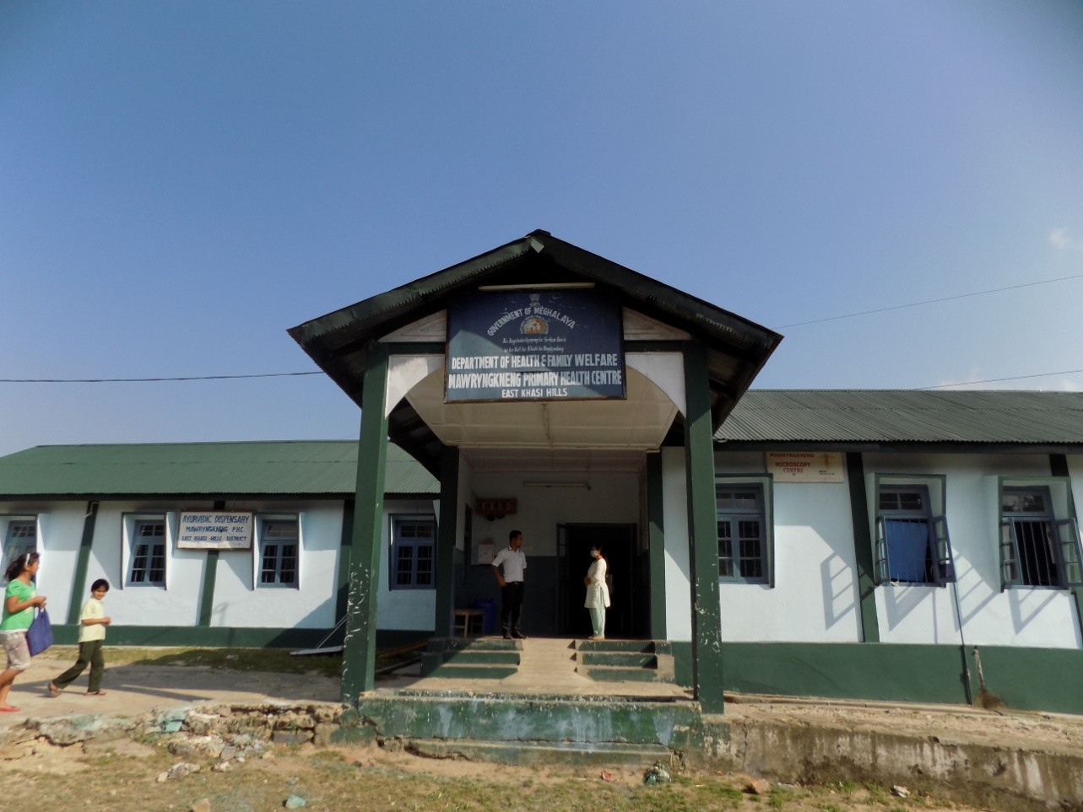
Mawryngkneng Primary Health Centre(PHC)

The PHC did not have the equipments for conducting ECGs or Ultrasounds. All cases requiring these services were referred to Ganesh Das Hospital.
There wasn’t any patient charter for the public. Neither was there any separate room for female patients. The PHC did not have a Blood Storage facility. There was no generator or inverter for power back-up.
A PHC worker also informed us that often pregnancy kits are bought by them as they are not adequately supplied by the government. The medicine supply is also not adequate and they have to be bought from outside sources. When this happens, the patients have to be charged to recover the amount spent by the PHC workers from own pockets.
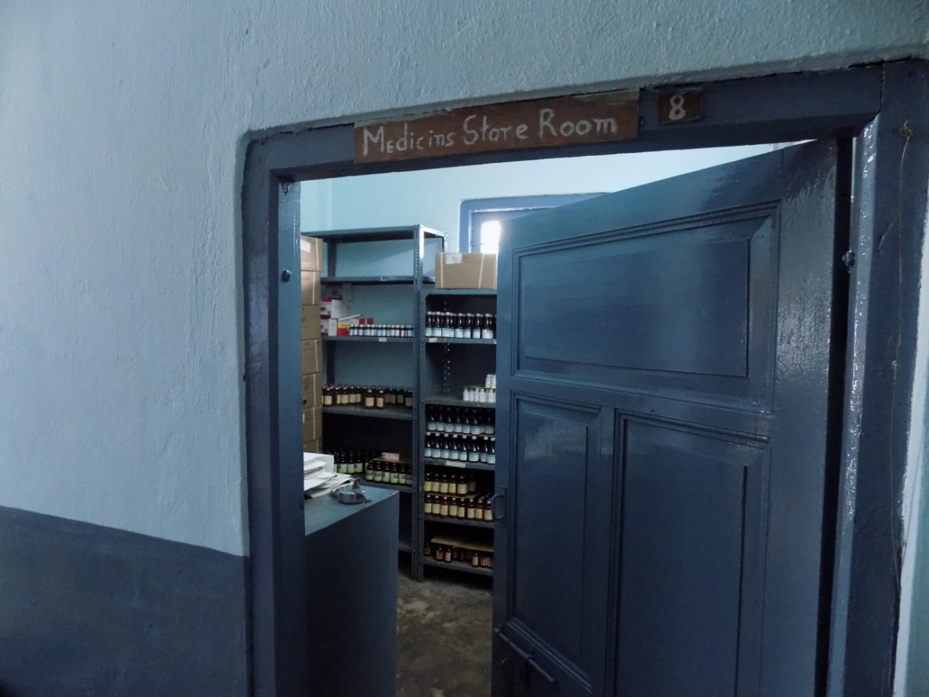
Medicine Store Room at Mawryngkneng PHC

The IPHS are not being followed properly at the PHC. We hope steps are taken to comply with the guidelines at the earliest. This is necessary for heeding to the health requirements of the surrounding villages.

Conclusion
The above points throw light on the poor and improper implementation of IPHS guidelines by the public health centres in Meghalaya. Although, the survey covered only two districts, it reflects the situation of the entire state. The persons interviewed also shared similar thoughts. As a consequence, the public are not being able to reap the fruits that were originally intended through the schemes and policies of the Government. Further, there are reports that ambulances have not been able to penetrate several remote villages. Even incidences have been reported where pregnant women have been asked to walk for a distance till the reach the point where the ambulance is waiting. The ambulances are inadequately equipped. In another incident, a baby’s thumb was cut as a result of negligence while cutting the umbilical cord. There is a severe lack of infrastructure. Even where medicines are being supplied properly, the patients are not being able to avail them.
As a consequence of all these problems, it is the common public at the end who has to suffer. The rich can afford to go to Private Hospitals, but the poor have to bear the brunt. All pay taxes and have a right to health. There is a dire need for immediately improving the infrastructure in the state, be it roads or the health centres. It is essential that the Government ensure that all issues are dealt with at the earliest and the health situation improved.

