Introduction
Following the fact finding report that was done by the HRLN Team on the 26th April 2016, it has told that there were maternal and infant deaths in the hospital, therefore a Social Activist from HRLN Meghalaya Unit then conducted a few case study in this area.
A Social Activist, Ribor Kharsynniang, travel to Nongpoh on the 7th of November and met a few staff of the Hospital, but unfortunately the demonetisation by the government has created an error in this fact finding or case study which the social activist has to return back to Shillong and went back to the area on the 14th to resume the study. The name of the villages and the victims of death (infant and maternal) were extracted from the office of the DMHO, District Medical Health Officer, Nongpoh, Ri-Bhoi District. Only three case studies were able to be conducted in this area which includes of two cases in a village name Mawdiangum which 2-3 kilometres from Nongpoh town by walk and one in Nongagang, a village name in Marngar which is 15-20 kilometres from Nongpoh town.
Ri-Bhoi district is one of the well known fertile districts in the state for agriculture which most of the people depends on agriculture for livelihood. Also, because this is the harvesting season, therefore activist visited the villages early in the morning, 6-9 a.m in the morning for data collection.
Case study- 1 (Maternal death)

Melina Dohling
Mawdiangum, Nongpoh, Ri-Bhoi District,
Meghalaya.
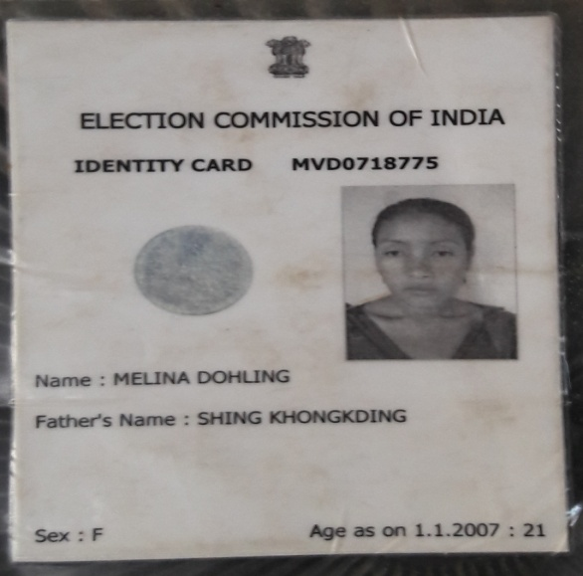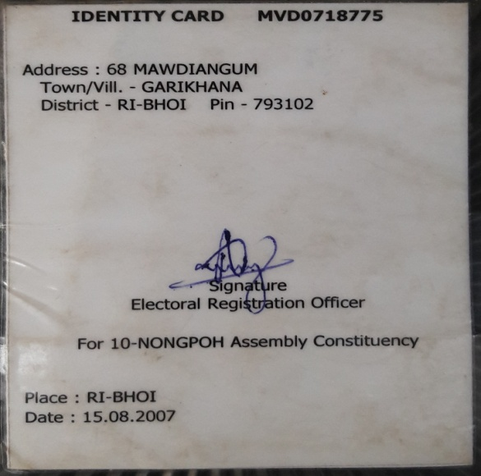
Fig. 1.1: Election card of (L) Melina Dohling.

The Social Activist visited Mawdiangum on the 16th November, 2016 at 7 a.m in the morning to meet the family of a (L) Melina Dohling. There are 11 members in the family, including the 4 children of late Melina where the father (Shing Khongkding) and the 3rd child of these two are the only bread winners of the family. The family depends on agricultural for livelihood where the father and the rest already went to the field because it is the harvesting season where there were only the mother (Pharmon Dohling) and one of her daughter and the three children of Late Melina at home. Pharmon couldn’t involve in any cultivation activities ever since Melina passed away on the 30th January, 2016.
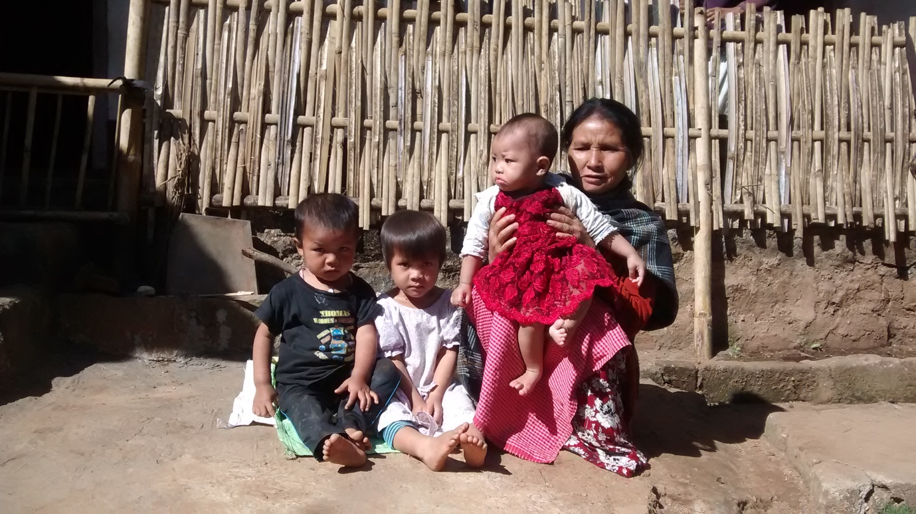
Fig 1.2: The three children of (L) Melina Dohling and their grandmother (Pharmon Dohling), where as the eldest one is at school.

Melina married a man named, Kanlus Syngkli, a labourer who depends on daily wages for livelihood, at the age of 24 and left behind her 4 children, 2 boys and 2 girls where the eldest is a boy of 6 years old, the second is a girl of 4 years old, the third is a boy of 2 years old and the fourth is a girl of 9 months old.
In an interaction with the mother of (L) Melina with the presence of an ASHA worker of this village, I was told that Melina had a regular check up during her pregnancy period (ANC card has been misplaced) but she prefer to deliver a child at home. (L). Melina deliver the youngest daughter (9 months old now) on the 30th of January, 2016 and passed away on the same day, she had a normal delivery, but due to her weakness she was taken to the hospital after she delivers a child. Unfortunately, she couldn’t be saved which the doctors said that it was due to her low BP (blood pressure).

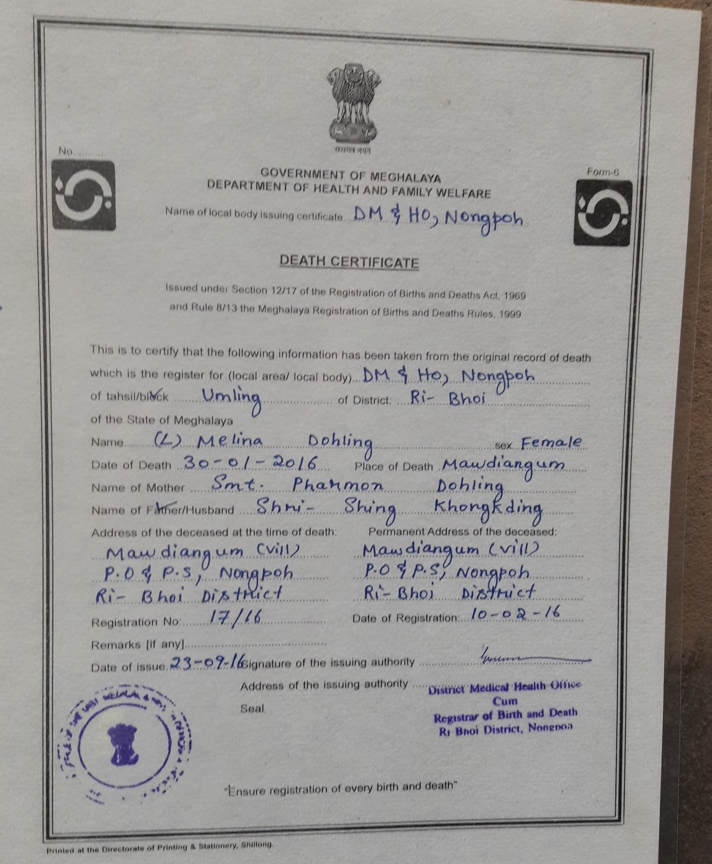
Figure: 1.3: Death certificate of (L) Melina Dohling.

Pharmon Dohling said it is such a challenge for the entire family, especially in terms of financial aspects because Kanlus Syngkli who is the father of these children also got married to another woman just after a few months when (L) Melina died and left the responsibility to her and her husband to raise these children. It is really a challenge for the family, but her husband, as a grandfather of the children, tends to ignore the hindrances but work very hard to look after these children as well.

Case study: 2 (Infant death)

Mother’s name: Cherrylindaris Marwein
Mawdiangum, Nongpoh, Ri-Bhoi District,
Meghalaya.

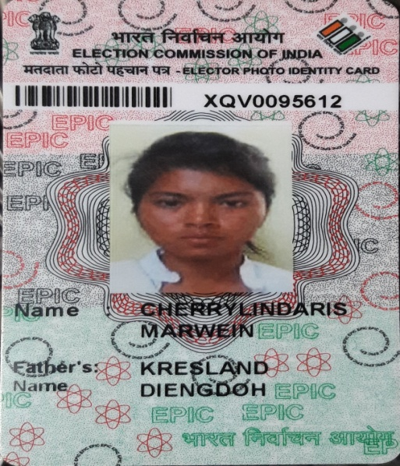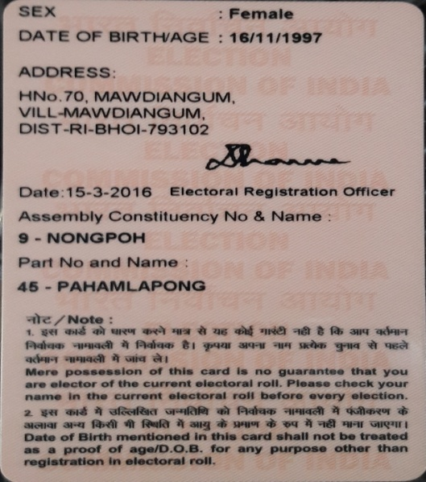
Fig 2.1: Election card of Cherrylindaris Marwein.

Cherrylindaris Marwein (the mother of a death infant) is a 19 years old woman from Mawdiangum, a village in Nongpoh of Ri-Bhoi District. Cherry is staying with her husband, Raju Thapa in his place along with her in-laws and the family depends on agriculture for livelihood.
Cherry said that she has not gone through any ANC check-ups because the couple started staying together only just before she delivers a child. She was admitted to a Civil Hospital, Nongpoh to deliver a child on the 24th October, 2016 which she delivers a child on the same day itself, but on the 26th October she was asked to shift to a private hospital, Bethany Hospital, Nongpoh for a Sepsil Screen (Blood test) since the Civil Hospital doesn’t have any equipments to conduct the test but the child passed away on the same day at 12:30 p.m., just after two days of delivery. Also, she said that the doctors claim that the child was having fever.
When asked about the death certificate of a child, she said that the certificate was not yet issued (usually it takes time to receive a death certificate or it will be issued only they ask for it) but she only have the discharge slip with her which she couldn’t provide that too because she had kept with her mother in another locality where they are staying.
The mother with tearful eyes said that she was hoping that the baby will be saved by the doctor safe hands, but unfortunately the baby couldn’t be saved and left with no words but to accept it as the will of God.

Case study: 3 (Infant death)
Mother’s name: Dipali Syiem
Nongangang, Marngar, Ri-Bhoi District
Meghalaya.
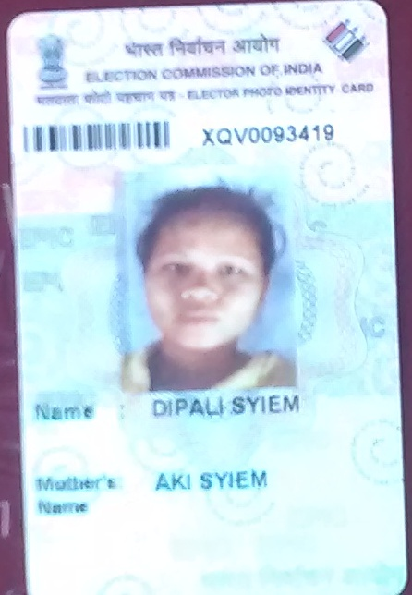
Fig 3.1: Election card of Dipali Syiem
Dipali Syiem (mother of a death infant) is a 19 years old woman from Nongangang, Marngar Ri-Bhoi District staying with her husband and her parents and her younger brother. She was with her younger brother at home who was preparing for his exam where as the rest had gone to the field since it is the harvesting season because her family also depends on agriculture.
Dipali got married when she was 18 years old and expecting to have her first child by mid February 2016, she had done all her ANC before the delivery but unfortunately on the 5th of December 2016 she was admitted to a PHC in Marngar where she was referred to a Civil Hospital, Nongpoh but due to the unavailability of the equipments to ensure the safety of a child she was again referred to Ganesh Das Hospital, Shillong but due to a limited time that they have she was referred to a private hospital, Bethany Hospital, Nongpoh on the 6th of December, 2015 which she had a premature birth of 7 months which the baby couldn’t be saved.
Dipali also said she accept the incidence as the will of God but she is also praying God to let him keep the second child because she is already 5 months pregnant now and she concluded that she and her husband will be very happy to have a child.

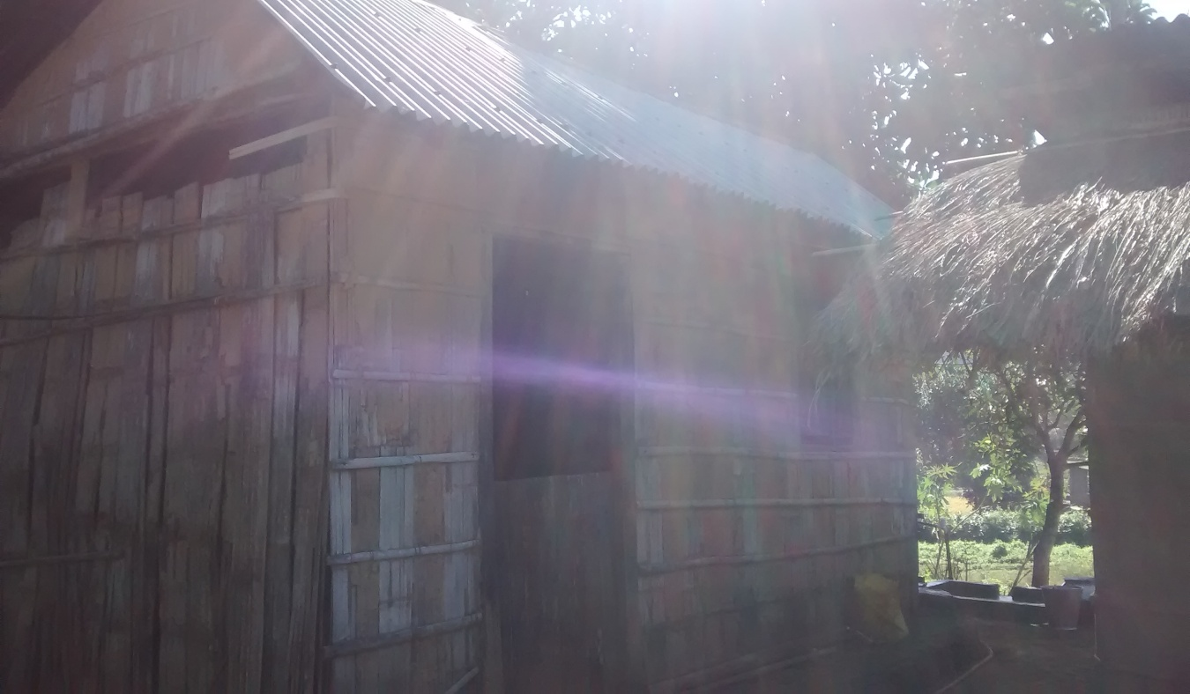
Fig 3.2: The Kaccha house where the family of Dipali are staying.

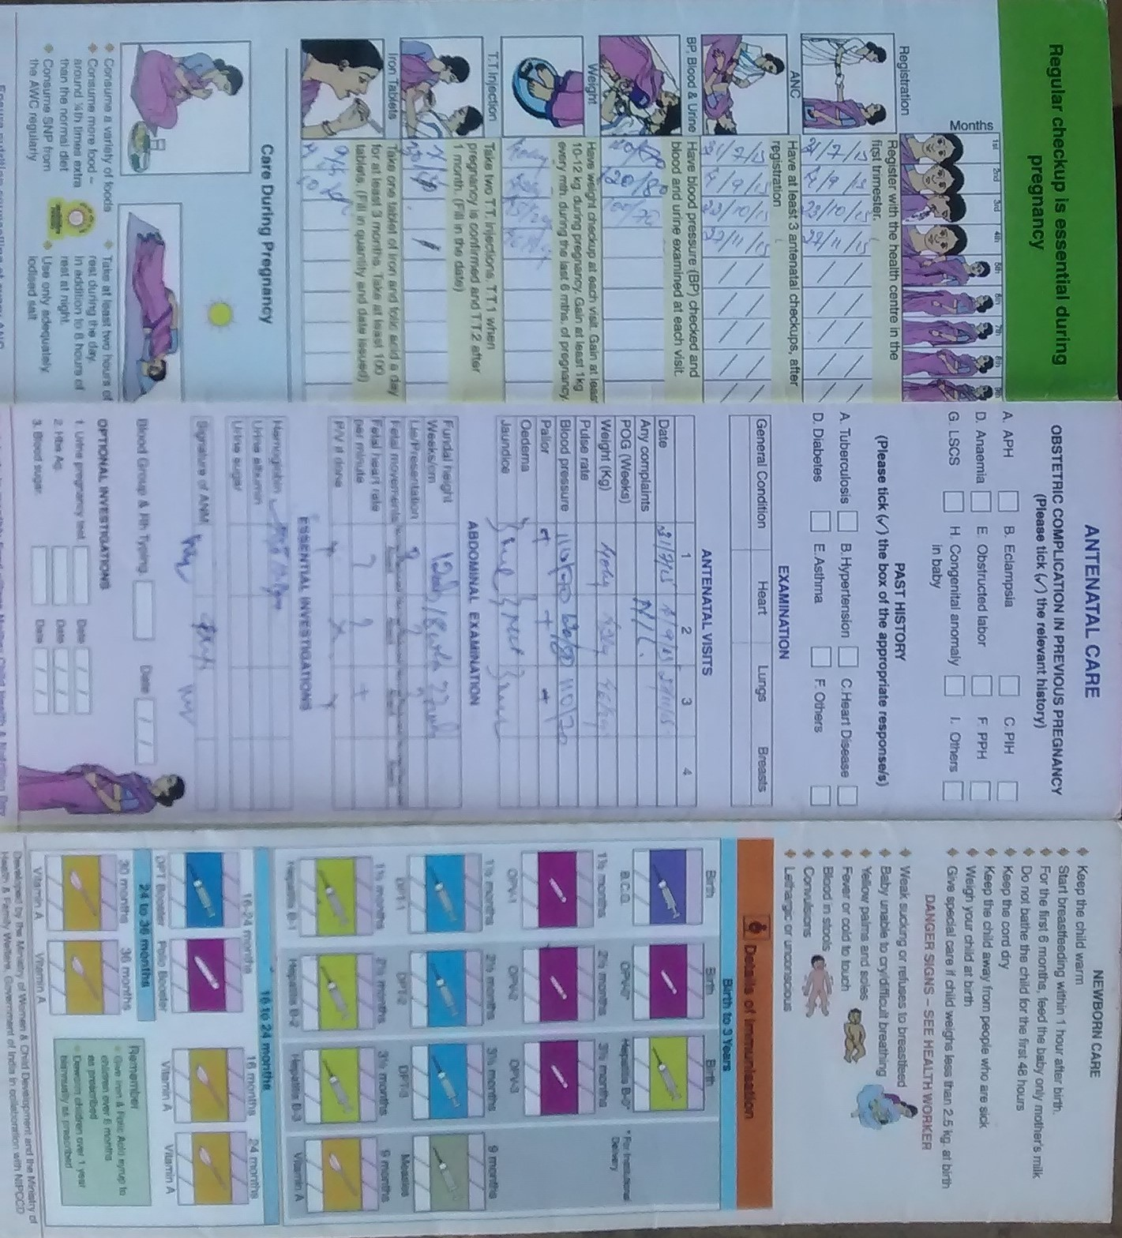
Fig 3.3: An ANC check up card which shows that Dipali has done all the check-ups before she deliver a child in 2015.
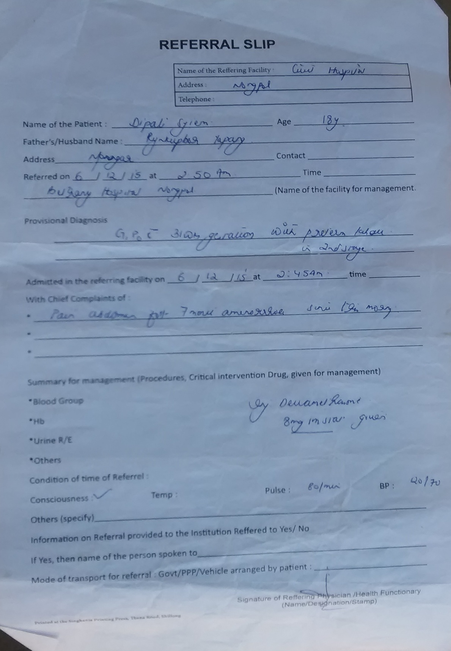
Fig 3.4: Referral Slip by Civil Hospital, Nongpoh

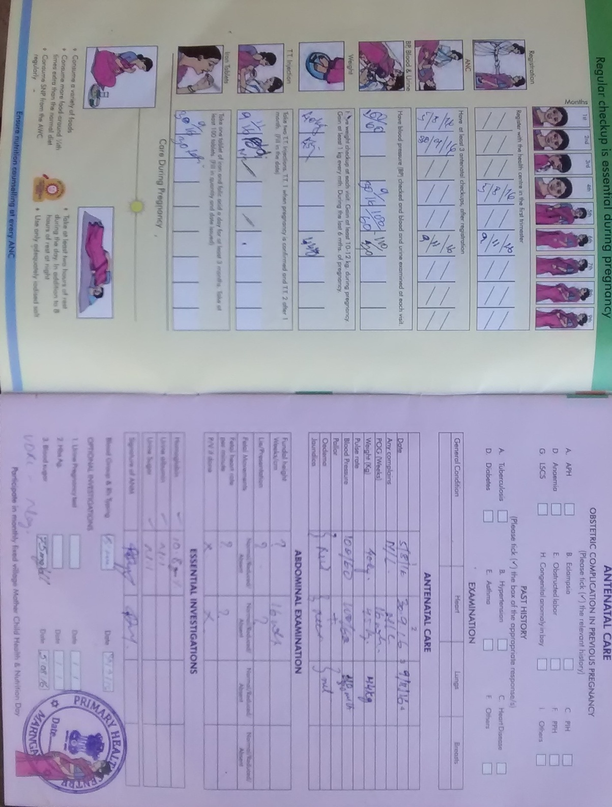
Fig 3.5: An ANC card which shows that she has done three ANC till date for the present pregnancy.

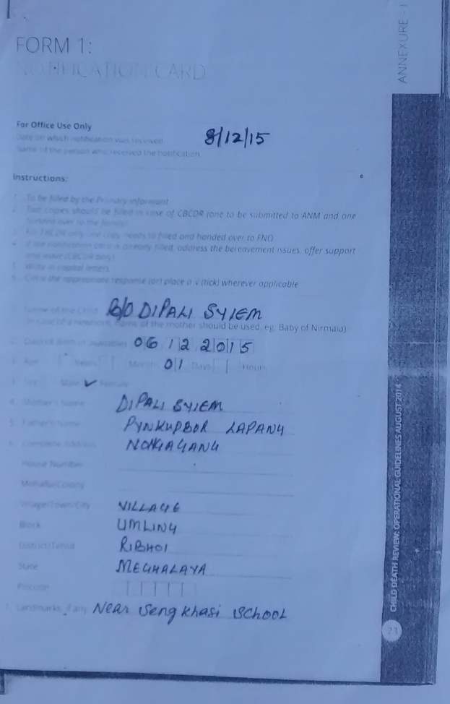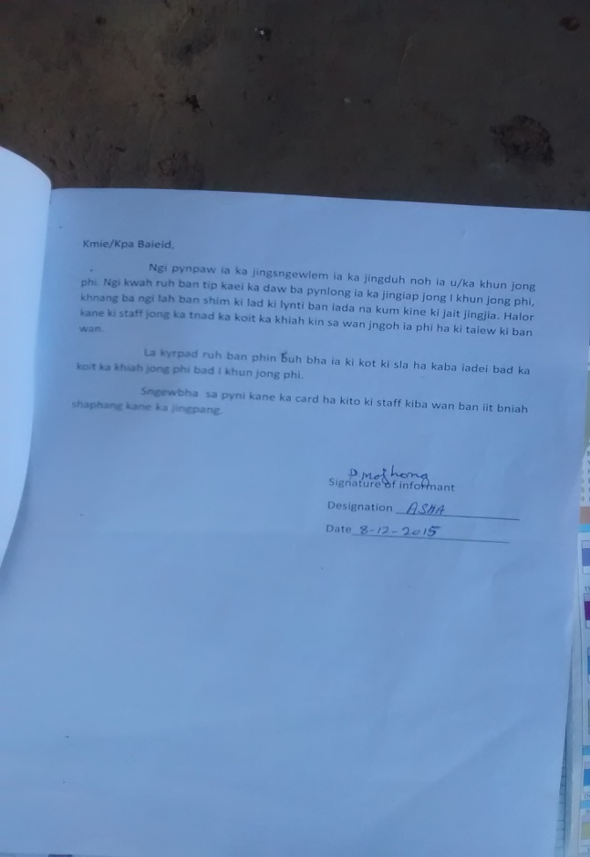
Fig 3.6: the condolence letter sent by the PHC through an ASHA worker, Proni Majhong which also inform her to keep the important documents for the future purpose.
Though the social activist able to conduct only three case studies, but there are also other reported and recorded maternal and infant deaths in the district. The recorded and reported deaths of mothers are:
SL No | Name | Village
1. | Agnes Bey | Pahamdumu
2. | Elizabeth | Purduwa in Marngar

The recorded and reported deaths of the infants are:
SL No | Mother’s name | Village
1. | Baby of Rosanna Lapang | Umsawnongkharai
2. | Baby of Mi Lapang | Narrang
3. | Baby of Morilda Bongring | Pahampdem

Conclusion
In an interaction with the ASHA workers and as well as the respondents of the above case studies of both the villages, Mawdiangum and Marngar, they said that the most difficulties or the challenges specifically face by the mothers is that whenever there is a complication birth is that the Hospital doesn’t have an Operation Theatre (OT) which they are being referred to Ganesh Das Hospital in Lawmali, Shillong or to a private hospital, Bethany Hospital in Nongpoh itself. “It is such a challenge, child delivery is a case which you never know what is going to happen in a few moments also”. If the mother who was admitted to a District Civil Hospital, it means she was referred there from a Public Health Centre (PHC) which is already a long way and if she is again referred to Ganesh Das Hospital in Shillong, it will be a very long distance and you never know what is going to happen on the way and especially if Ambulance and staffs from the hospital are not coming along. She also added, if the mother is referred to Bethany Hospital, the poor mothers from the poor family background have to take loans from the other well to do villagers in order to pay the bill in the hospital. For instance, Dipali Syiem who delivered a child at Bethany Hospital has to take a loan to pay the bill of more than Rs 17,000 and that is after 5,000 was deducted from the Megha Health Insurance Scheme (MHIS).

