Wahkaji PHC
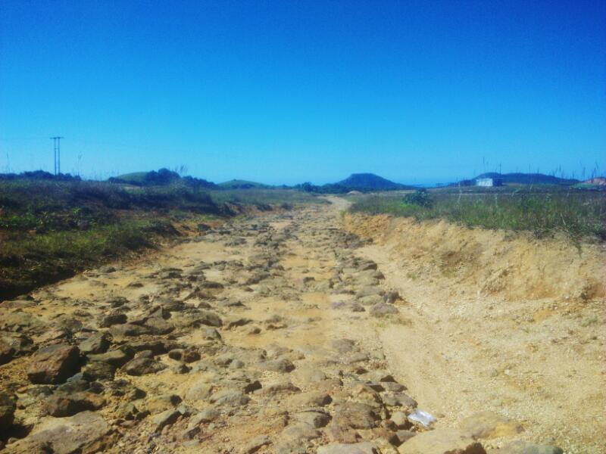
Fig. 2.1: The road condition to Wahkaji.

Wahkaji village which is located in the South West Khasi Hills District of Meghalaya, one of the newest districts in the state which came into existence in 2012. Wahkaji is just 56 kms away from Mawkyrwat (the main town in the district which is also the head-quarter of the district), but it took 4-5 hours to travel by Tata Sumo, Mahindra Maxx or a Bolero pick up due to the pitiable road condition.

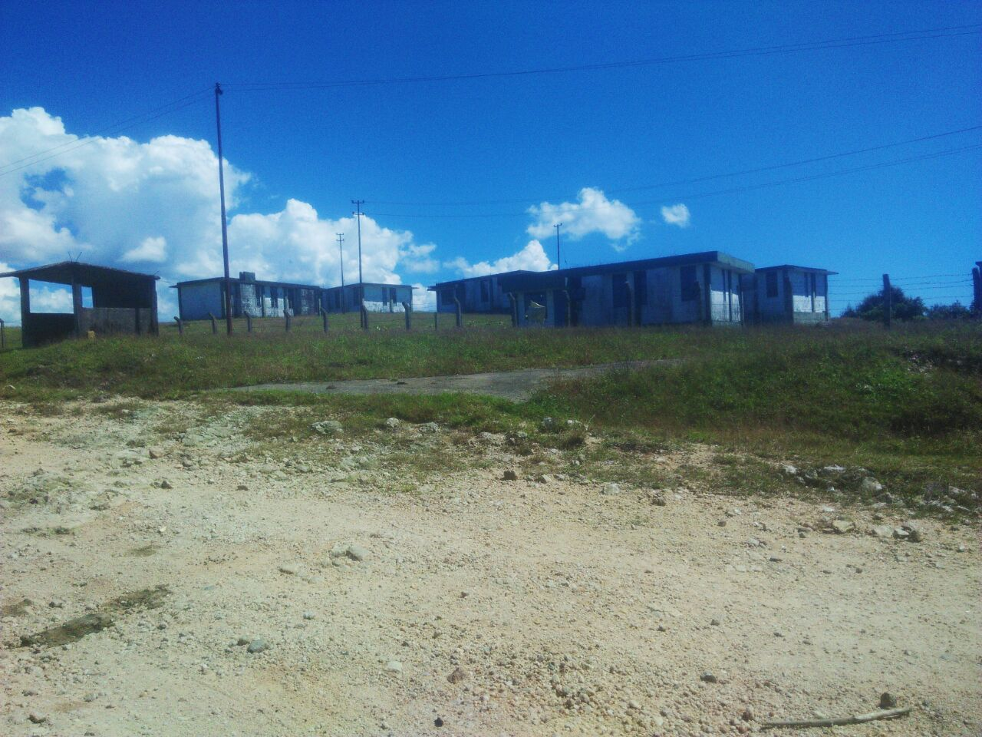
Fig.2.2: Wahkaji PHC
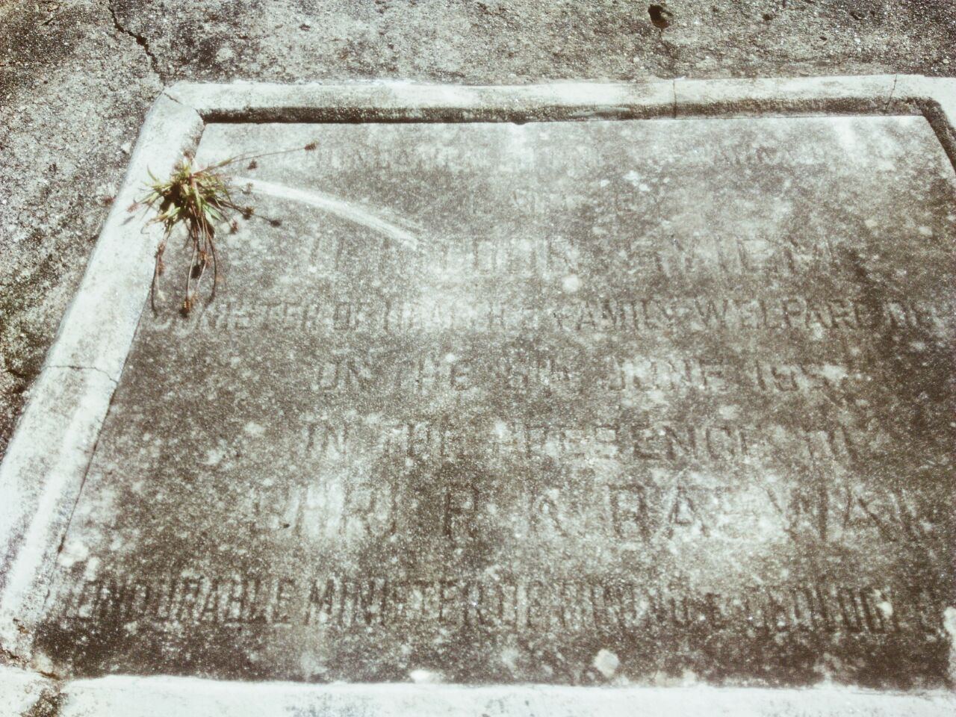
Fig.2.3: A foundation stone of the Wahkaji PHC.

About the PHC
On the 17th October 2016, at 10:00 am in the morning on the way to Domiasiat, uranium mining area, we stop at Wahkaji PHC which came into existence or structure in the year 1997 as a sub-centre which was then upgraded into a PHC later. This PHC is supposed to provide service to more than 90 villages in this area. But unfortunately, though the Wahkaji PHC came into a structure in the year 1997 but has never been able to serve the people of that area since then, it doesn’t even have any water or electricity supply. The PHC is supposed to serve more than 90 villages in that area, but has failed to due to its dysfunctional. It was later, in the year 2005, handed to the UCIL to run that PHC which was supposed to be under the Development Projects which they (UCIL) also promised schools and good roads of the UCIL that was sanctioned in exchange of the Uranium Mining in this area, but it has failed and remained dysfunctional because the UCIL hasn’t given any motive to conduct the mining in this area by many NGOs and also some villages. Therefore, the PHC still remain dysfunctional till date.
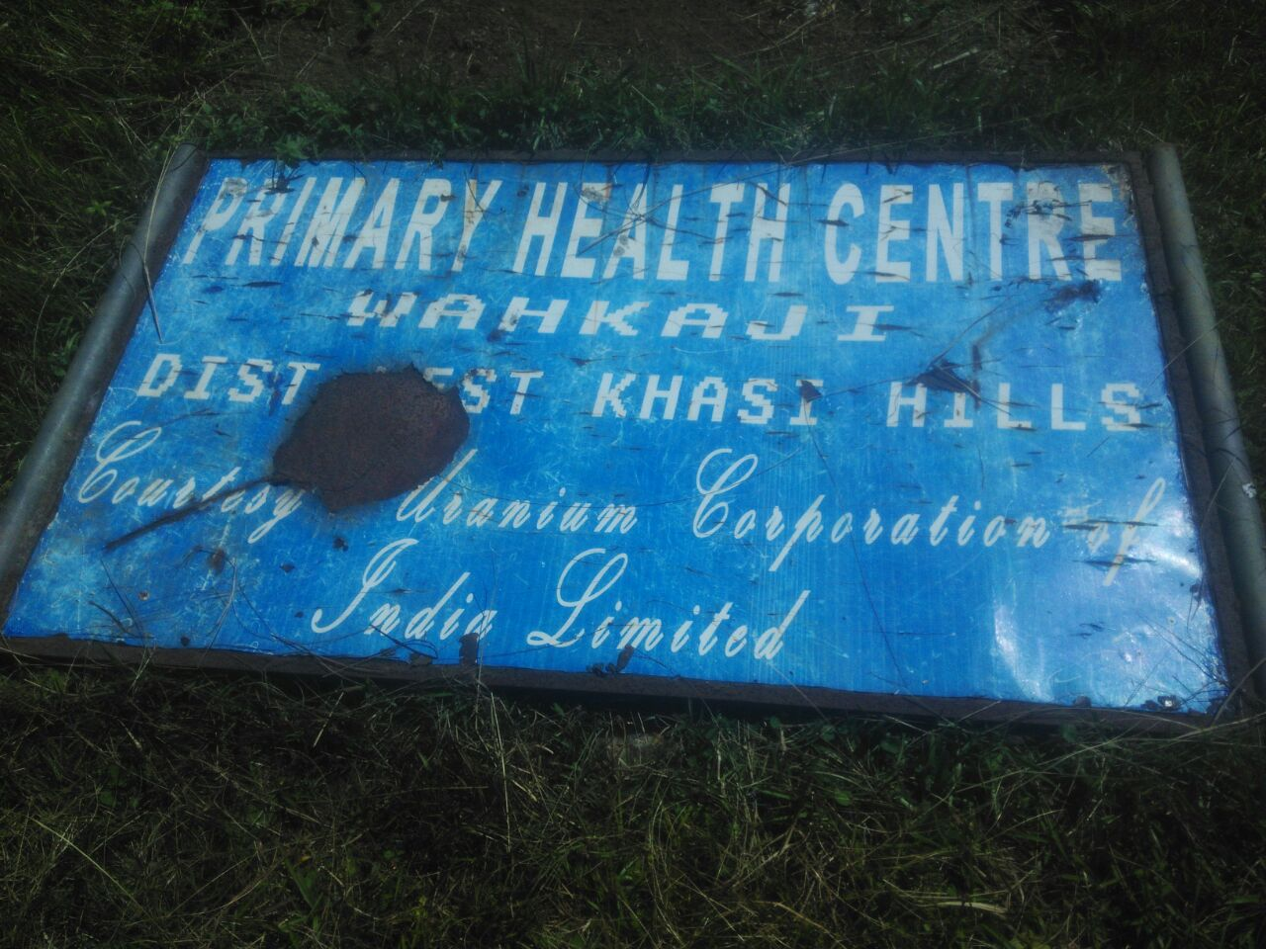
Fig. 2.4: The Board lying down at the UCIL IB (Inspection Bungalow) which shows that the UCIL runs the PHC but actually left it dysfunctional.

Fact finding
In interaction with one of the members, Shem who is also the Vice President of Khasi Students Union (KSU) one of the youth groups in the State said, “ever since the PHC came into an existence, but it has never been functioned as it should be”. He also added that, people in this area has not yet been benefitted from this PHC, in fact it was made as a place to house the security, scientists and officials of the UCIL and the government.
According to the Meghalaya Times, it was mentioned that the KSU has met and demand the State Government that it should intervene and restore the PHC back to the state from the then Health Minister, A.L. Hek and the newly appointed Health Minister Kong Roshan Warjri which they have promised that they will look into the matter and assured that the inspection will be conducted and the PHC shall be made functional at the earliest. (Shillong Times, 2016)

Like it has been mentioned that there are more than 90 villages depends on this PHC for medical needs and assistance but this PHC run by the UCIL has done nothing to the people. In 2009, in the news posted by the Nagaland Post, it demonstrate that the people including the children, pregnant mothers along with their spouses from villages like Nongtnger, Mawthabah, Phlangdiloin, etc., trekked to this PHC for medical assistance, but has to returned back home because there was no doctors. (Nagaland Post, 2009)
In the interaction with the village Secretary of Domiasiat, one of the villages with a huge amount of Uranium deposited said that though his village also falls under the jurisdiction of the Wahkaji PHC, but due to its dysfunctional mode, the people cannot obtain any medical facilities from this PHC, but they have to travel to Ranikor which is 25 kms away from this area for medical assistance, in spite of the pitiable road condition. He also added that not only the medical facilities that have been neglected, but due to the unavailability of the doctors and staffs, the people in this area cannot also obtain a birth certificate for their children. (SP News Agency, 2012)
Also, in interactions with a member of the KSU, Village Secretary of Domiasiat and the shopkeepers where we stop while returning from the Uranium mining area, the response was the same, i.e. because the company, UCIL, was not granted the permission to conduct the mining activities in this area therefore though it has taken the responsibility to run the PHC, but it has not even made it functional.
Though the KSU from this District has met the Ministers regarding this issue, but it seems the government hasn’t taken any visible action which may lead to the functional PHC at the earliest for the benefit of the people to assist the people in this area in terms of medical facilities. (Shillong Times, 2016)
Therefore, in concluding the General Secretary of the South West Khasi Hills District, Trulywell Lyngdoh said that neglecting such a PHC also resulted the failure of the state government to provide health care facilities to the people is also a negligence of human right. (Meghalaya Times, 2016)
Hence, since there are not enough of primary information regarding the PHC, HRLN Meghalaya Unit will seek information regarding the status and the ongoing action of the government through an RTI Act in order to go on with the necessary legal actions for the benefits of the people in this area.
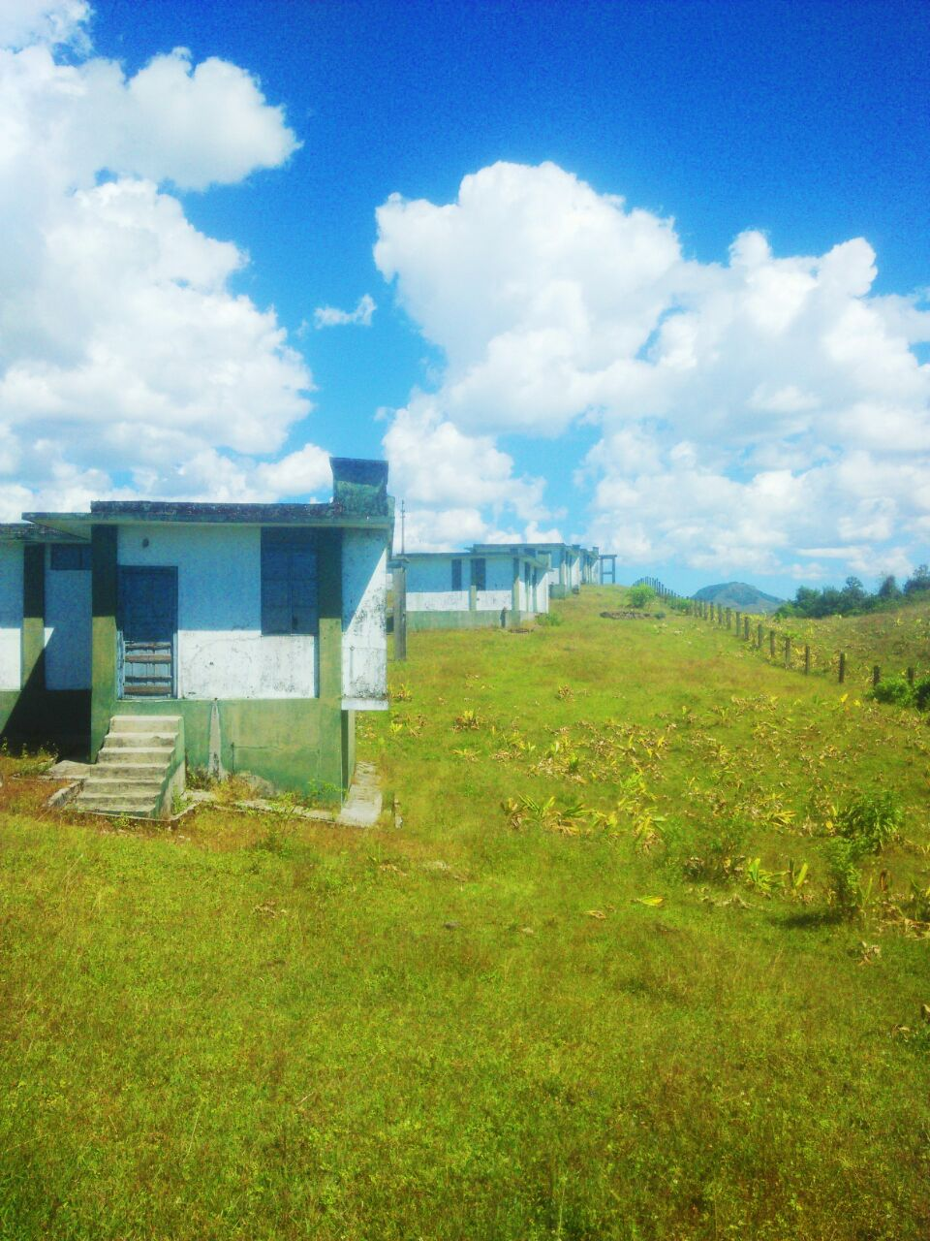
Fig. 2.5: The PHC quarters of the PHC left unused.
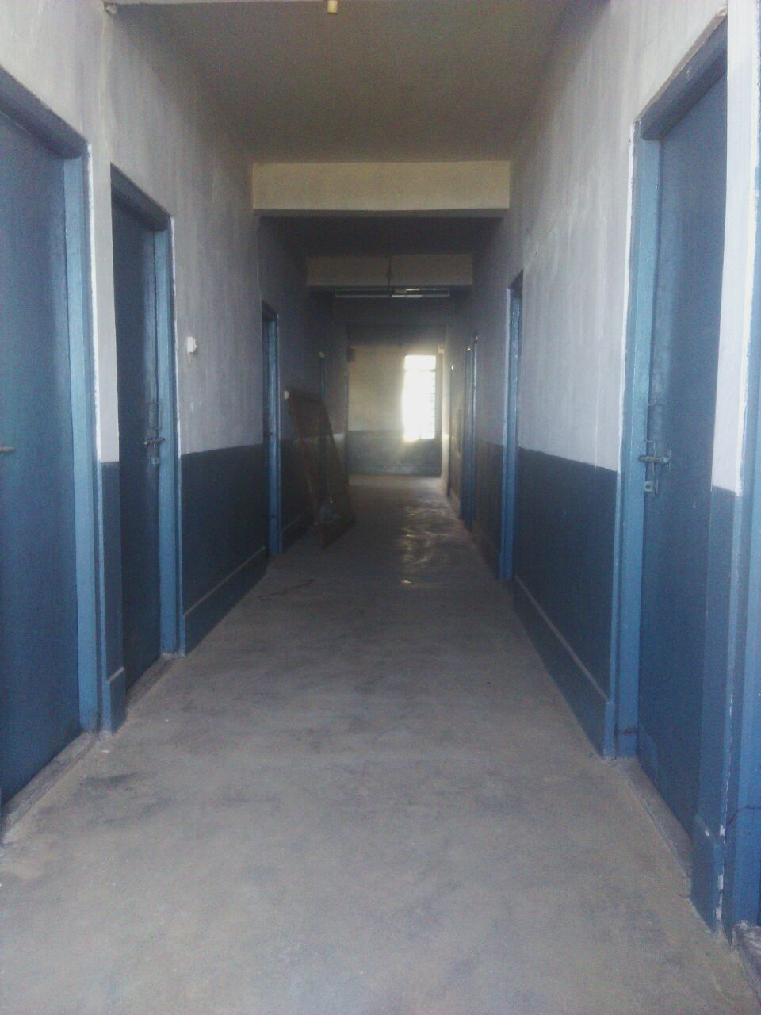
Fig. 2.6: The corridor inside the PHC.

References:
- Meghalaya Times. (2016). UCIL still hopeful of access to Meghalaya’s uranium. Shillong: Meghalaya Times.
- Nagaland Post. (2009). UCIL-funded projects dysfunctional in Meghalaya. Dimapur: Nagaland Post.
- Shillong Times. (2016). Demand for Nongstoin-Mawthabah road project gains momentum. Shillong: Shillong Times.
- Shillong Times. (2016). Demand for restoration of Wahkaji PHC. Shillong: Shillong Times.
- Shillong Times. (2016). Make Wahkaji PHC functional: KSU. Shillong: Shillong Times.
- SP News Agency. (2012). Government should take it back the PHC at Wahkaji from UCIL. Shillong: SP News Agency.

